**Weekly Milestone 2 - Designing**  
**Definition:** Determine how and where the camera/sensor should be mounted on the Brilliant Pad, determine required dimensions  
**Deliverable:** Drawing of expected placement, dimensions of mounts  
**Expected Date of Completion:** 1/28

There are two places where the camera can be placed for prototyping: on top of the control module, or on top of the lid next to the control panel.

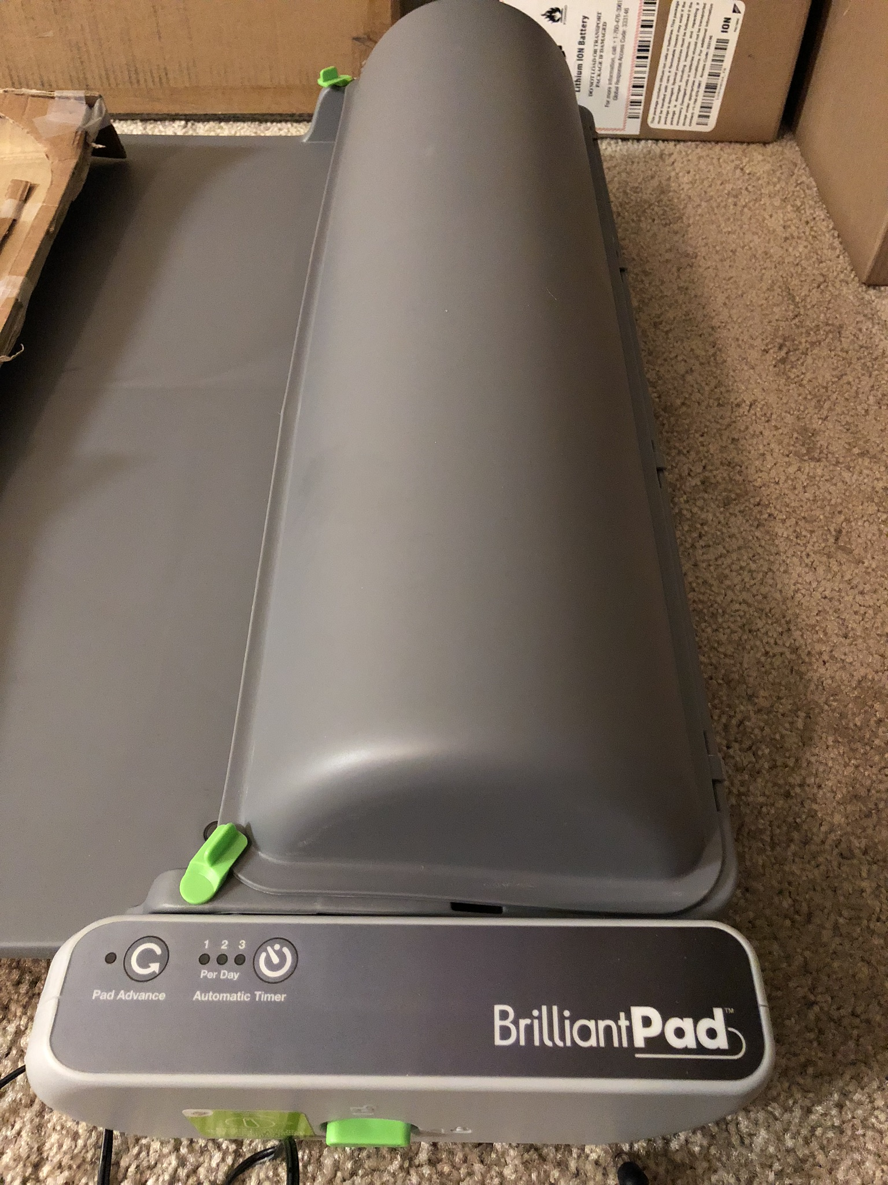

We will need to prototype several mechanical designs to see what camera positions will allow us to accurately classify how much waste there is. As there are also two cameras and two Raspberry Pi’s (Pi Zero and Pi 3), separate designs for each camera will have to be made.

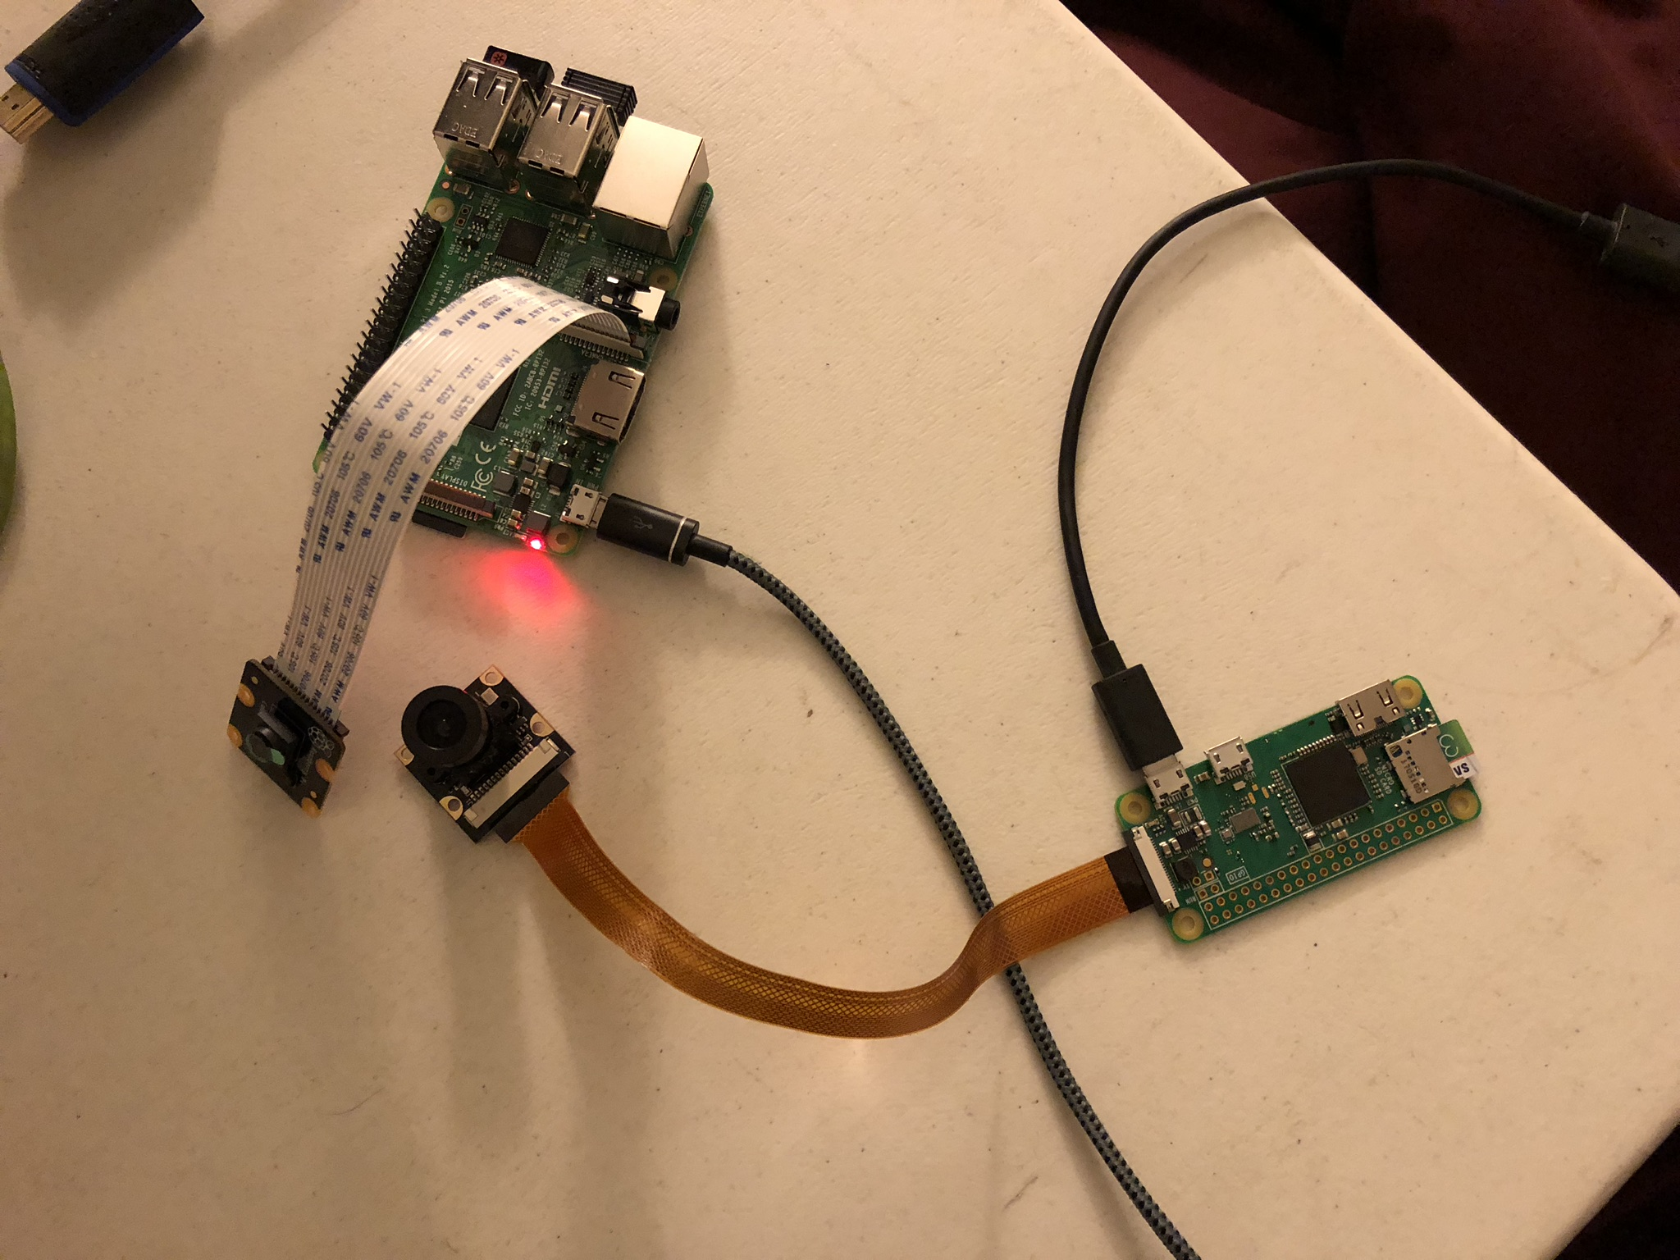

<https://www.raspberrypi-spy.co.uk/2013/05/pi-camera-module-mechanical-dimensions/>

<https://www.raspberrypi.org/documentation/hardware/raspberrypi/mechanical/README.md>